**ACKNOWLEDGEMENT:-**

I would like to express my greatest gratitude to the people who have helped and supported me throughout my project. I am grateful to my teacher, **MR BHARAT RANA** for his continuous support for the project from initial advice and encouragement till this day.

A special thank goes to my group partner who helped me in completing this project by providing their interesting ideas and thoughts which made this project easier and accurate.

Also I would like to express my gratitude towards the school authority and also my parents due to which we were able to complete the project successfully.

**CONTENTS:-**

* System Description at a Glance
  + Subway’s History
  + Need For System
  + Feasiblity
  + Objectives
* Database Design
* Entity Realtionship Diagram
* Table Structure
* Project Explorer
* Program Output
* Bibliography

**ABOUT SUBWAY:-**

SUBWAY AT DAMAN

**SUBWAY** is an American fast food restaurant franchise that primarily sells submarine sandwiches and salads. It is owned and operated by Doctor's Associates, Inc. Subway is one of the fastest growing franchises in the world with 40,735 restaurants in 102 countries and territories. It is the largest single-brand restaurant chain and the largest restaurant operator globally. Subway's main operations office is in **Milford, Connecticut**.

[](http://en.wikipedia.org/wiki/File:Alternative_subway_logo.svg)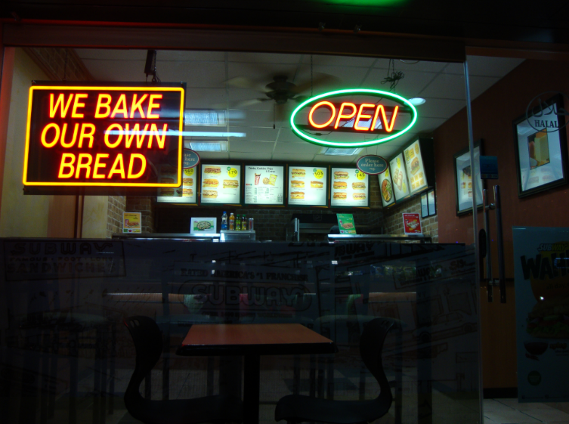

**SUBWAY’S HISTORY:-**

In 1965, [Fred DeLuca](http://en.wikipedia.org/wiki/Fred_DeLuca)  starts "Pete's Super Submarines" in [Bridgeport, Connecticut](http://en.wikipedia.org/wiki/Bridgeport,_Connecticut), and in the following year they formed Doctor's Associates Inc to oversee operations of the restaurants as the franchise expanded. In 1968, the shop began using the name "Subway" for the first time. The first Subway on West Coast was opened in Fresno, California in 1978. The first Subway outside of North America opened in Bahrain, in December 1984. In 2004, Subway began opening stores in Walmart supercenters. Subway's best-selling sandwich the B.M.T., originally stood for Brooklyn Manhattan Transit but now stands for "Biggest, Meatiest and Tastiest". Subway uses the advertising slogan "Eat Fresh".



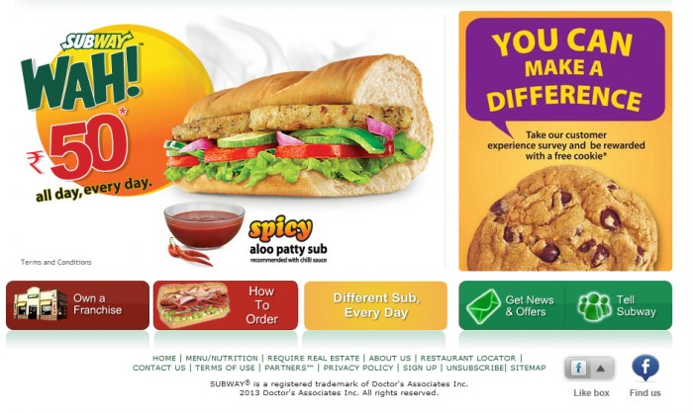

**NEED FOR THE SYSTEM:-**

* It is user friendly, needs no training to operate.
* The chance of committing mistakes while entering data in the computer is almost impossible.
* The system analyzes Subway’s Transactions and automatically provides a statistical data of Subway’s Scale and Profit.
* The System reduces the man power thus saving restaurant’s money and prevents overcrowding of the attendees.
* The System takes care of the Security of the data most efficiently.
* The System reduces the chances of redundancy in accounts and manages the account accurately.

**FEASIBILITY:-**

* **TECHNICAL FEASIBLITY:**

Technical feasibility is considered with the technical requirements for the system.

Weather the software and hardware required for the system is available with the

Organization or can be obtained with ease.

* **HARDWARE FEASIBLITY:**

The proposed system will need an Intel i-7 processor and HP LaserJet color printer.

* **SOFTWARE REQUIREMENTS:**

The proposed system will be developed in the JAVA database package. And fortunately the JAVA is available with the organization.

* **ECONOMICAL FEASIBLITY:**

Development of the system can be fruitful if it provides cost effectiveness i.e. whatever cost is supposed to be invested for the purposed system for a period of approval.

* **MAINTENANCE:**

The proposed system to workable with its effectiveness for at least 5 years we consider that 10% of cost will be cost of the hardware per annum. Also the consumable item like stationary would cost 2000 per annum. The maintenance of the system can be handled by one EDP.

* **TRAINING:**

As the proposed system is quite user friendly and menu driven such that normal man can easily grasp the operation procedures.

* **INTANGIBLE BENEFITS:**

Apart from the tangible benefits the intangible benefits are always the real motivation behind any system development. Because for any modern organization money is not that much important as the professional work environment and proper MIS system.

**Objectives:-**

* To allow more than one user work per day and on each data.
* To reduce the usage of the manpower.
* To bring accuracy to your management.
* To allow fast accessing of data.
* To make the system more friendly to native use.
* To avoid data redundancy and inconsistency.
* To reduce the load of calculation and accounts.
* To provide a comfortable platform for customers for enquiry and personal purchasing.

**DATABASE DESIGN:-**

**TABLE STRUCTURES**

**DESCRIPTION: - Details of Members**

**DESCRIPTION:- Contact Details**

**DESCRIPTION: - Order Details**

**DESCRIPTION: - Details of Total Collection**

**DESCRIPTION: - Details of Total Collection Per day.**

**TABLE STRUCTURE**

**Table: - Member**

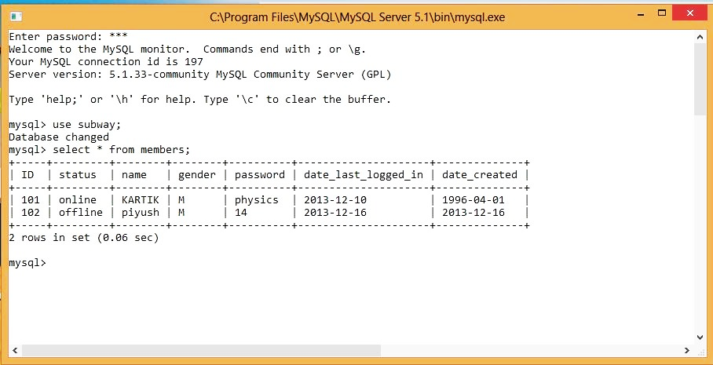

MySQL Command:-

create table members

(ID integer(5) primary key,

status varchar(7) not null,

name varchar(30) not null,

gender char(1) not null,

password varchar(30) not null,

date_last_logged_in date not null,

date_created date not null);

**Table: - Contact Info**

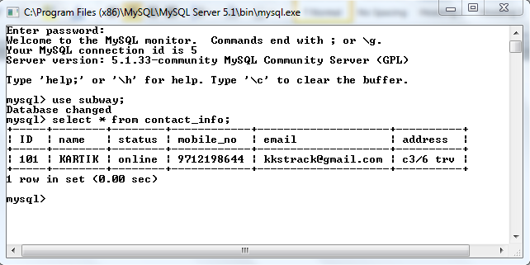

MySQL Command:-

create table contact_info

(ID integer(5) primary key,

name varchar(30) not null,

status varchar(7) not null,

mobile_no bigint(10) not null,

email varchar(40) not null,

address varchar(50) not null);

**Table: - Orders**

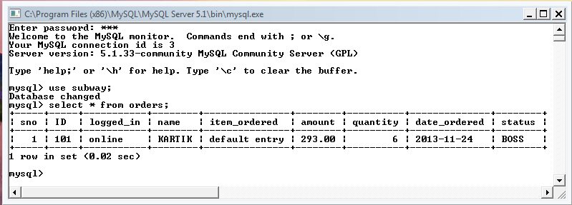

MySQL Command:-

create table orders

(sno integer(5) not null,

ID integer(5) not null,

logged_in varchar(7),

name varchar(30) not null,

item_ordered varchar(50) not null,

amount decimal(8,2) not null,

quantity integer(5) null,

date_ordered date,

status varchar(6) not null);

**Table: - Total Collection**

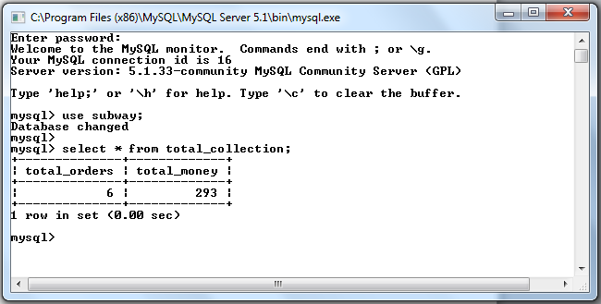

MySQL Command:-

create table total_collection

(total_orders integer(8),

total_money integer(8));

**TABLE: - TOTAL COLLECTION PERDAY**

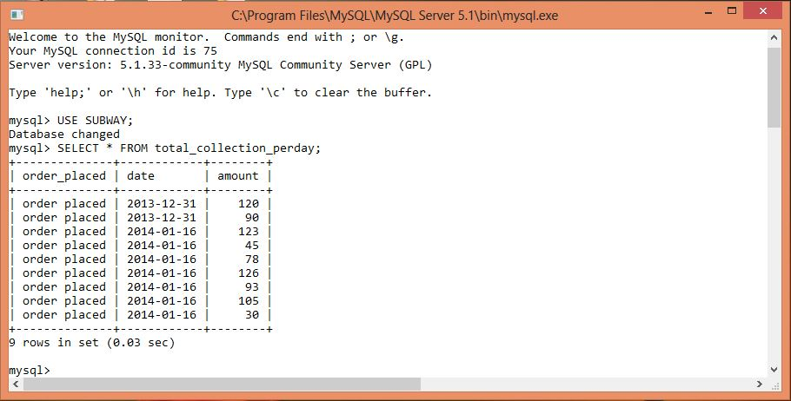

create table total_collection_perday

(order_placed varchar(15),

date date,

amount integer(8));

**Project Explorer**

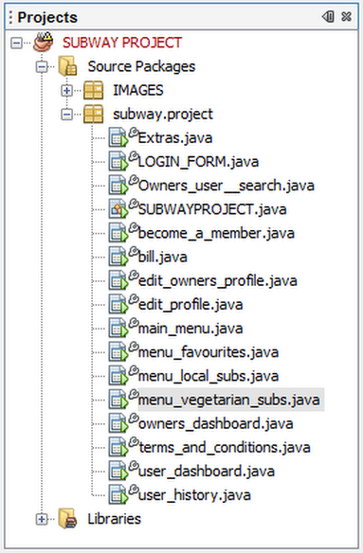

**Main Frame: Login Form**

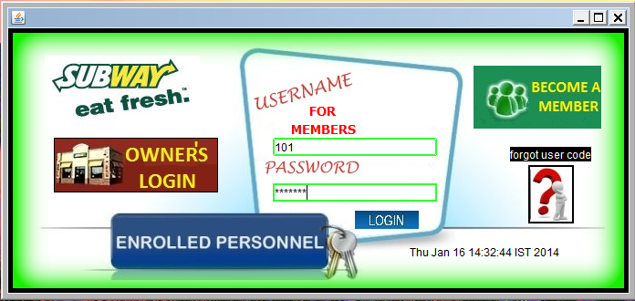

**SOURCE CODE: Login Form.java**

import java.sql.*;

import javax.swing.ImageIcon;

import javax.swing.JOptionPane;

**private void loginBtnActionPerformed(java.awt.event.ActionEvent evt) {**

String ID=usernameTf.getText().trim().toLowerCase();

String pwd=new String(pwdTf.getPassword());

**try** {

Class.forName("java.sql.Driver");

Connection con=DriverManager.getConnection("jdbc:mysql://localhost:3306/subway","root","123");

Statement stmt=con.createStatement();

String check_ID="select password from members where ID='"+ID+"';";

ResultSet rs=stmt.executeQuery(check_ID);

while(rs.next()){

String pwd_from_mysql=rs.getString("password");

if(pwd.equals(pwd_from_mysql)){

String set_offline="update members set status='offline';";

String set_offline1="update contact_info set status='offline';";

String set_offline2="update orders set logged_in='offline';";

String set_online="update members set status='online' where ID="+ID;

String set_online1="update contact_info set status='online' where ID="+ID;

String set_online2="update orders set logged_in='online' where ID="+ID;

Calendar c = Calendar.getInstance();

String set_date="update members set date_last_logged_in='"+(c.get(Calendar.YEAR))+"-"+(c.get(Calendar.MONTH)+1)+"-"+(c.get(Calendar.DATE))+"' where ID="+ID+" ;";

stmt1.executeUpdate(set_offline);

stmt2.executeUpdate(set_offline1);

stmt6.executeUpdate(set_offline2);

stmt3.executeUpdate(set_online);

stmt4.executeUpdate(set_online1);

stmt5.executeUpdate(set_online2);

stmt7.executeUpdate(set_date);

new user_dashboard().setVisible(true);

dispose();

}

**else**{

JOptionPane.showMessageDialog(null, "Incorrect password. Please try again.");

pwdTf.setText("");

}

}

rs.close();

stmt.close();

con.close();

}

**catch(Exception e**){

JOptionPane.showMessageDialog(this,e.getMessage());

}

}

**private void becomememberBtnActionPerformed(java.awt.event.ActionEvent evt) {**

new terms_and_conditions().setVisible(true);

dispose();

}

**private void fgtpwdBtnActionPerformed(java.awt.event.ActionEvent evt) {**

String mobile=(JOptionPane.showInputDialog(null, "enter your mobile number that you entered during sign up!")).toLowerCase().trim();

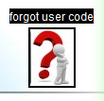

**try**{

Class.forName("java.sql.Driver");

Connection con = DriverManager.getConnection("jdbc:mysql://localhost:3306/subway","root","123");

Statement stmt=con.createStatement();

String query="select ID from contact_info where mobile_no='"+mobile+"';";

ResultSet rs=stmt.executeQuery(query);

while(rs.next()){

String mysql_username=rs.getString("ID");

JOptionPane.showMessageDialog(null,"your username is: "+mysql_username);

}

}

**catch (Exception e)** {

}

}

**private void usernameTfKeyTyped(java.awt.event.KeyEvent evt) {**

char ch= evt.getKeyChar();

if( ((ch>='a') && (ch<='z')) || ((ch>='A') && (ch<='Z')) ){

evt.consume();

}

}

**private void formWindowGainedFocus(java.awt.event.WindowEvent evt) {**

Calendar c = Calendar.getInstance();

time.setText("" +c.getTime());

}

**private void owner loginBtnActionPerformed(java.awt.event.ActionEvent evt){**

**try** {

Class.forName("java.sql.Driver");

Connection con = DriverManager.getConnection("jdbc:mysql://localhost:3306/subway","root","123");

Statement stmt = con.createStatement();

String get_owner_password="select password from members where ID=101 ;";

ResultSet rs = stmt.executeQuery(get_owner_password);

while(rs.next()){

String username_mysql=(rs.getString("password"));

String pwd = JOptionPane.showInputDialog(null, "PLEASE ENTER PASSWORD - password is "+ username_mysql );

if(pwd.equals(username_mysql)){

new owners_dashboard().setVisible(true);

dispose();

}

else

JOptionPane.showMessageDialog(null, "SORRY WRONG PASSWORD- password is "+ username_mysql);

}

}

**catch(Exception e)**{

}

}

**Main Frame: Become A Member Form**

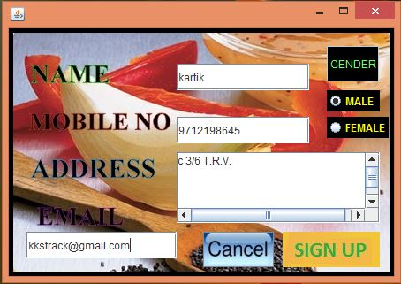

**SOURCE CODE: Become A Member.java**

import javax.swing.JOptionPane;

import java.sql.*;

import java.util.Calendar;

**private void signupBtnActionPerformed(java.awt.event.ActionEvent evt) {**

String name = nameTf.getText().trim().toLowerCase();

long mobile = Long.parseLong(mobnoTf.getText());

String address = addressTa.getText().trim().toLowerCase();

String email_id = emailTf.getText().trim().toLowerCase();

String password = " ";

String password1 = JOptionPane.showInputDialog("please select a password for your account");

String password2 =JOptionPane.showInputDialog("re-enter password to confirm");

if(password1.equals(password2)){

password=password1;

}

else{

JOptionPane.showMessageDialog(null, "the password you entered didn’t matched, please try again");

signupBtn.doClick();

}

if(name.equals("")||mobnoTf.getText().equals("")||password.equals("")||email_id.equals("")||address.equals(""))

JOptionPane.showMessageDialog(null, "All fields are mandatory.");

else{

**try** {

Class.forName("java.sql.Driver");

Connection con = DriverManager.getConnection("jdbc:mysql://localhost:3306/subway","root","123");

Statement stmt = con.createStatement();

String id = "select ID from members order by ID;";

ResultSet rs = stmt.executeQuery(id);

while(rs.next()){

int new_id = Integer.parseInt(rs.getString("ID"))+1;

idLb.setText(""+new_id);

usernameLb.setText(""+new_id);

pwdLb.setText(""+password);

}

String gender = " ";

if(maleRb.isSelected())

gender="M";

else

gender="F";

Calendar c = Calendar.getInstance();

String add_member = "insert into members values("+idLb.getText().trim()+",'offline','"+name+"','"+gender+"','"+password+"','"+(c.get(Calendar.YEAR))+"-"+(c.get(Calendar.MONTH)+1)+"- "+(c.get(Calendar.DATE))+"','"+(c.get(Calendar.YEAR))+"-"+(c.get(Calendar.MONTH)+1)+"-"+(c.get(Calendar.DATE))+"');" ;

String update_contact_info="insert into contact_info values("+idLb.getText().trim()+",'"+name+"','offline',"+mobile+",'"+email _id+"','"+address+"');";

stmt.executeUpdate(add_member);

stmt.executeUpdate(update_contact_info);

rs.close();

stmt.close();

con.close();

congratsMsg.setVisible(true);

dispose();

}

**catch(Exception e)**{

JOptionPane.showMessageDialog(this,e.getMessage());

new become_a_member().setVisible(true);

dispose();

}

}

}

**private void mobnoTfFocusLost(java.awt.event.FocusEvent evt) {**

String mobile=mobnoTf.getText().trim();

if(mobile.equals("")){

}

else{

int initial_digit=Integer.parseInt(mobile.substring(0, 1));

int length=mobile.length();

if(length==10){

if(initial_digit==8|| initial_digit==9 || initial_digit==7){

String duplicate_check="select mobile_no from contact_info where mobile_no="+mobile+";";

**try**{

Statement stmt=connect();

ResultSet rs=stmt.executeQuery(duplicate_check);

while(rs.next()){

String mysql_mobno=(rs.getString("mobile_no")).toLowerCase().trim();

if(mobile.equals(mysql_mobno)){

JOptionPane.showMessageDialog(null, "Sorry! this number has already been taken by our existing user. please try a different mobile number.");

mobnoTf.setText("");

}

}

}

**catch (Exception e)**{

JOptionPane.showMessageDialog(null, e.getMessage());

}

}

else{

JOptionPane.showMessageDialog(null, "This kind of mobile number does not exist in India. Please enter a VALID number.");

mobnoTf.setText("");

}

}

else{

JOptionPane.showMessageDialog(null, "Plz enter a 10 digit number");

mobnoTf.setText("");

}

}

}

**private void loginActionPerformed(java.awt.event.ActionEvent evt) {**

new LOGIN_FORM().setVisible(true);

congratsMsg.setVisible(false);

}

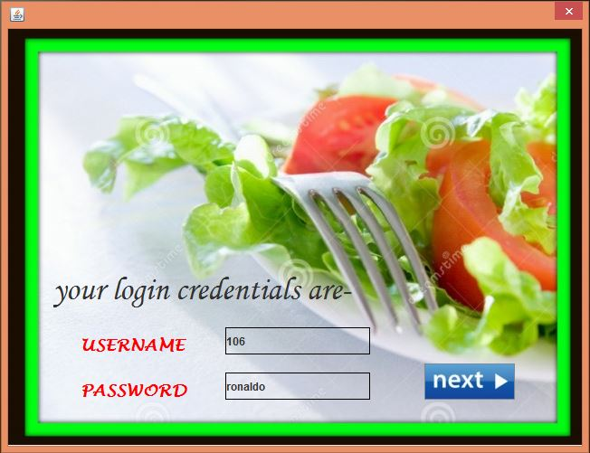

**private void jButton1ActionPerformed(java.awt.event.ActionEvent evt) {**

new LOGIN_FORM().setVisible(true);

dispose(); }

public Statement connect() throws Exception{

Class.forName("java.sql.Driver");

Connection con = DriverManager.getConnection("jdbc:mysql://localhost:3306/subway","root","123");

Statement stmt = con.createStatement();

return stmt;

}**Main Frame: TERMS AND CONDITIONS**

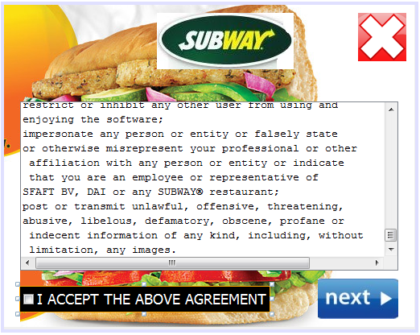

**SOURCE CODE: Terms and Conditions.java**

**private void jButton1ActionPerformed(java.awt.event.ActionEvent evt) {**

new LOGIN_FORM().setVisible(true);

dispose();

}

**private void cbItemStateChanged(java.awt.event.ItemEvent evt) {**

if(cb.isSelected()){

next.setEnabled(true);

}

else

next.setEnabled(false);

}

**private void formWindowGainedFocus(java.awt.event.WindowEvent evt) {**

next.setEnabled(false);

}

**private void nextActionPerformed(java.awt.event.ActionEvent evt) {**

new become_a_member().setVisible(true);

dispose();

}

USERS SECTION

**Main Frame: USER DASHBOARD**

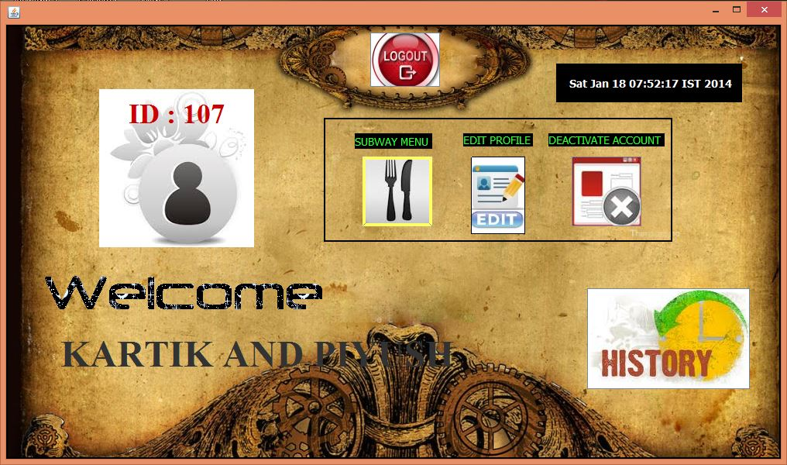

**SOURCE CODE: User Dashboard.java**

**private void jButton1ActionPerformed(java.awt.event.ActionEvent evt) {**

String password= JOptionPane.showInputDialog(null, "Please enter your password for security reasons.");

**try** {

Class.forName("java.sql.Driver");

Connection con = DriverManager.getConnection("jdbc:mysql://localhost:3306/subway","root","123");

Statement stmt = con.createStatement();

String get_password = "select password from members where status = 'online' and ID>101 ;";

ResultSet rs = stmt.executeQuery(get_password);

while(rs.next()){

String actual_password=rs.getString("password");

if(password.equals(actual_password)){

int final_answer = JOptionPane.showConfirmDialog(null, "ARE YOU SURE.. PROFILE ONCE DELETED CANNOT BE RESTORED BACK");

if(final_answer==0){

String delete_records_from_members="delete from members where status='online' ;";

String delete_records_from_contact_info="delete from contact_info where status='online' ;";

String delete_records_from_orders="delete from orders where logged_in='online' ;";

Statement stmt1=con.createStatement();

Statement stmt2=con.createStatement();

Statement stmt3=con.createStatement();

stmt1.executeUpdate(delete_records_from_members);

stmt2.executeUpdate(delete_records_from_contact_info);

stmt2.executeUpdate(delete_records_from_orders);

JOptionPane.showMessageDialog(null, "YOUR ACCOUNT HAVE BEEN DELETED. THANK YOU FOR BEING WITH SUBWAY.");

new LOGIN_FORM().setVisible(true);

dispose();

}

}

else{

JOptionPane.showMessageDialog(null, "Incorrect password. Please try again.");

}

}

rs.close();

stmt.close();

con.close();

}

**catch(Exception e)**{

JOptionPane.showMessageDialog(this,e.getMessage());

}

}

**private void jButton2ActionPerformed(java.awt.event.ActionEvent evt) {**

new main_menu().setVisible(true);

dispose();

}

**private void jButton3ActionPerformed(java.awt.event.ActionEvent evt) {**

new edit_profile().setVisible(true);

dispose();

}

**private void jButton4ActionPerformed(java.awt.event.ActionEvent evt) {**

new LOGIN_FORM().setVisible(true);

dispose();

}

**private void formWindowGainedFocus(java.awt.event.WindowEvent evt) {**

Calendar c = Calendar.getInstance();

datelb.setText(" " +c.getTime());

**try{**

Class.forName("java.sql.Driver");

Connection con = DriverManager.getConnection("jdbc:mysql://localhost:3306/subway","root","123");

Statement stmt = con.createStatement();

String get_user_info = "select name, ID from members where status='online' ;";

ResultSet rs=stmt.executeQuery(get_user_info);

while(rs.next()){

String username_mysql=(rs.getString("name").toUpperCase());

String id_mysql=rs.getString("ID");

username.setText(""+username_mysql);

id.setText("ID : "+id_mysql);

}

}

**catch(Exception e)**{

JOptionPane.showMessageDialog(this,e.getMessage());

}

}

**Main Frame: User Profile**

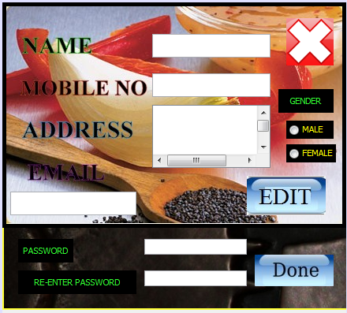

**SOURCE CODE: User profile.java**

**private void gActionPerformed(java.awt.event.ActionEvent evt) {**

String name=a.getText().trim().toLowerCase();

String gender="";

if(e.isSelected())

gender = "M";

else

gender = "F";

String address=c.getText().trim().toLowerCase();

String email_id = d.getText().trim().toLowerCase();

String password= "";

String password1 = new String(h.getPassword());

String password2 = new String(i.getPassword());

if(password1.equals(password2)){

password=password1;

}

else{

JOptionPane.showMessageDialog(null, "the password you entered didn’t matched, please try again");

g.doClick();

}

if(name.equals("")|| password.equals("")||email_id.equals("")||address.equals(""))

JOptionPane.showMessageDialog(null, "All fields are mandatory.");

else{

**try** {

long mobile = Long.parseLong(b.getText());

Class.forName("java.sql.Driver");

Connection con=DriverManager.getConnection("jdbc:mysql://localhost:3306/subway","root","123");

Statement stmt=con.createStatement();

Statement stmt1=con.createStatement();

Statement stmt2=con.createStatement();

String update_members="update members set name='"+ name +"' , gender='"+gender+"' , password='"+password+"'where ID=101 ;";

String update_contact_info= "update contact_info set name='"+ name +"' , mobile_no="+mobile+" ,email='"+email_id+"' , address='"+address+"' where ID=101 ;";

String update_orders= "update orders set name='"+ name +"' where ID=101 ;";

stmt.executeUpdate(update_members);

stmt1.executeUpdate(update_contact_info);

stmt2.executeUpdate(update_orders);

stmt.close();

con.close();

JOptionPane.showMessageDialog(null, "changes saved successfully");

new user_dashboard().setVisible(true);

dispose();

}

**catch(Exception e)**{

JOptionPane.showMessageDialog(this,e.getMessage());

dispose();

}

}

}

private void bFocusLost(java.awt.event.FocusEvent evt) {

String mobile=b.getText().trim();

if(mobile.equals("")){

JOptionPane.showMessageDialog(null, "this field is mandatory.");

}

else{

int initial_digit=Integer.parseInt(mobile.substring(0, 1));

int length=mobile.length();

if(length==10){

if(initial_digit==8|| initial_digit==9 || initial_digit==7){

String duplicate_check="select mobile_no from contact_info where mobile_no="+mobile+" and status='offline' and ID>101 ;";

**try**{

Class.forName("java.sql.Driver");

Connection con = DriverManager.getConnection("jdbc:mysql://localhost:3306/subway","root","123");

Statement stmt=con.createStatement();

ResultSet rs=stmt.executeQuery(duplicate_check);

while(rs.next()){

String mysql_mobno=(rs.getString("mobile_no")).toLowerCase().trim();

if(mobile.equals(mysql_mobno)){

JOptionPane.showMessageDialog(null, "Sorry! this number has already been taken by our existing user. please try a different mobile number.");

b.setText("");

}

}

**catch(Exception e)**{

JOptionPane.showMessageDialog(null, e.getMessage());

}

}

else{

JOptionPane.showMessageDialog(null, "This kind of mobile number does not exist in India. Please enter a VALID number.");

b.setText("");

}

}

else{

JOptionPane.showMessageDialog(null, "Please enter a 10 digit number ONLY");

b.setText("");

}

}

}

private void bKeyTyped(java.awt.event.KeyEvent evt) {

char ch = evt.getKeyChar();

if( ((ch>='0') && (ch<='9')) ){

evt.consume();

}

}

**private void jButton1ActionPerformed(java.awt.event.ActionEvent evt) {**

new owners_dashboard().setVisible(true);

dispose();

}

**Main Frame: Main Menu**

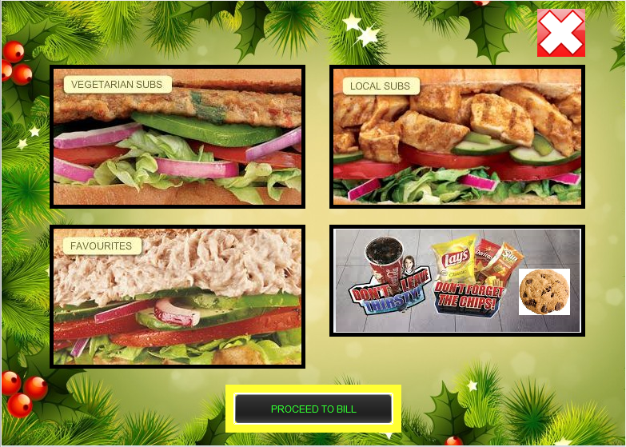

**SOURCE CODE: Main Menu.java**

private void jButton1ActionPerformed(java.awt.event.ActionEvent evt){

new menu_favourites().setVisible(true);

dispose();

}

private void jButton2ActionPerformed(java.awt.event.ActionEvent evt){

new Extras().setVisible(true);

dispose();

}

private void jButton3ActionPerformed(java.awt.event.ActionEvent evt) {

new menu_local_subs().setVisible(true);

dispose();

}

private void jButton4ActionPerformed(java.awt.event.ActionEvent evt) {

new menu_vegetarian_subs().setVisible(true);

dispose();

}

**private void formWindowGainedFocus(java.awt.event.WindowEvent evt) {**

**try** {

Class.forName("java.sql.Driver");

Connection con = DriverManager.getConnection("jdbc:mysql://localhost:3306/subway","root","123");

String query = "select count(name) as count from orders where logged_in='online' and status='unpaid';";

Statement stmt=con.createStatement();

ResultSet rs=stmt.executeQuery(query);

while(rs.next()){

int count=Integer.parseInt(rs.getString("count"));

if(count==0){

nextBtn.setText("NO BILLS PENDING");

nextBtn.setEnabled(false);

}

else{

nextBtn.setText("PROCEED TO BILL");

}

}

}

**catch (Exception e)**{

JOptionPane.showMessageDialog(null, e.getMessage());

}

}

private void nextBtnActionPerformed(java.awt.event.ActionEvent evt) {

new bill().setVisible(true);

dispose();

}

private void jButton5ActionPerformed(java.awt.event.ActionEvent evt) {

new user_dashboard().setVisible(true); dispose(); }

**Main Frame: VEGETERIAN SUB**

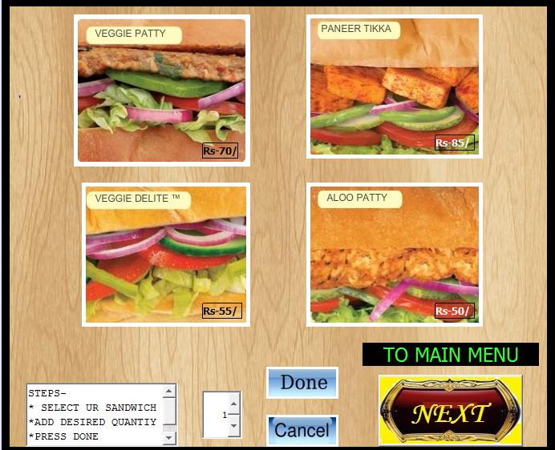

**SOURCE CODE: Vegeterian sub.java**

**private void jButton1ActionPerformed(java.awt.event.ActionEvent evt) {**

doneBtn.setEnabled(true);

cancelBtn.setEnabled(true);

jButton2.setEnabled(false);

jButton3.setEnabled(false);

jButton4.setEnabled(false);

}

**private void jButton2ActionPerformed(java.awt.event.ActionEvent evt) {**

doneBtn.setEnabled(true);

cancelBtn.setEnabled(true);

jButton1.setEnabled(false);

jButton3.setEnabled(false);

jButton4.setEnabled(false);

}

**private void jButton3ActionPerformed(java.awt.event.ActionEvent evt) {**

doneBtn.setEnabled(true);

cancelBtn.setEnabled(true);

jButton1.setEnabled(false);

jButton2.setEnabled(false);

jButton4.setEnabled(false);

}

**private void jButton4ActionPerformed(java.awt.event.ActionEvent evt) {**

doneBtn.setEnabled(true);

cancelBtn.setEnabled(true);

jButton1.setEnabled(false);;

jButton2.setEnabled(false);

jButton3.setEnabled(false);

}

**private void cancelBtnActionPerformed(java.awt.event.ActionEvent evt) {**

jButton1.setEnabled(true);

jButton2.setEnabled(true);

jButton3.setEnabled(true);

jButton4.setEnabled(true);

doneBtn.setEnabled(false);

cancelBtn.setEnabled(false);

}

**private void doneBtnActionPerformed(java.awt.event.ActionEvent evt) {**

**try** {

Class.forName("java.sql.Driver");

Connection con = DriverManager.getConnection("jdbc:mysql://localhost:3306/subway","root","123");

String query="select ID from members where status='online';";

String query2="select name from members where status='online';";

String sno_query="select sno from orders order by sno desc;";

Statement stmt = con.createStatement();

ResultSet rs = stmt.executeQuery(query);

while(rs.next()){

int ID_mysql=Integer.parseInt(rs.getString("ID"));

Statement stmt1 = con.createStatement();

rs = stmt1.executeQuery(query2);

while(rs.next()){

String name_mysql=rs.getString("name");

Statement stmt3=con.createStatement();

rs = stmt3.executeQuery(sno_query);

while(rs.next()){

int sno = Integer.parseInt(rs.getString("sno"));

String item = " ";

int price;

if(jButton1.isEnabled()){

item="Vegie patty Sandwich";

price=70;

priceLb.setText(""+price);

}

else

if(jButton2.isEnabled()){

item="CVegie delite Sandwich";

price=55;

priceLb.setText(""+price);

}

else

if(jButton3.isEnabled()){

item="Paneer Tikka Sandwich";

price=80;

priceLb.setText(""+price);

}

else

if(jButton4.isEnabled()){

item="Aloo Patty Sandwich";

price=50;

priceLb.setText(""+price);

}

Calendar c = Calendar.getInstance();

int price_final= Integer.parseInt(priceLb.getText());

String order="insert into orders values("+(sno+1)+","+ID_mysql+",'online','"+name_mysql+"','"+item+"',"+Integer.parseInt(priceLb.getText())+","+quantity+",'"+(c.get(Calendar.YEAR))+"-"+(c.get(Calendar.MONTH)+1)+"-"+(c.get(Calendar.DATE))+"','unpaid');" ;

Statement stmt4=con.createStatement();

stmt4.executeUpdate(order);

String total_collection= "update total_collection set total_money = ( total_money + " + price_final*quantity + ") , total_orders = total_orders +1 ;";

String new_order_placed_today ="insert into total_collection_perday values ('order placed','"+(c.get(Calendar.YEAR))+"-"+(c.get(Calendar.MONTH)+1)+"-"+(c.get(Calendar.DATE))+"',"+price_final*quantity+");";

Statement stmt5=con.createStatement();

Statement stmt6=con.createStatement();

stmt5.executeUpdate(total_collection);

stmt6.executeUpdate(new_order_placed_today);

}

}

}

jButton1.setEnabled(true);

jButton2.setEnabled(true);

jButton3.setEnabled(true);

jButton4.setEnabled(true);

cancelBtn.setEnabled(false);

doneBtn.setEnabled(false);

thanksMsg.setVisible(true);

dispose();

**catch(Exception e)**{

jButton1.setEnabled(true);

jButton2.setEnabled(true);

jButton3.setEnabled(true);

jButton4.setEnabled(true);

cancelBtn.setEnabled(false);

doneBtn.setEnabled(false);

thanksMsg.setVisible(true);

dispose();

}

}

**private void jButton6ActionPerformed(java.awt.event.ActionEvent evt) {**

thanksMsg.setVisible(false);

new menu_favourites().setVisible(true);

}



**Main Frame: LOCAL SUBS**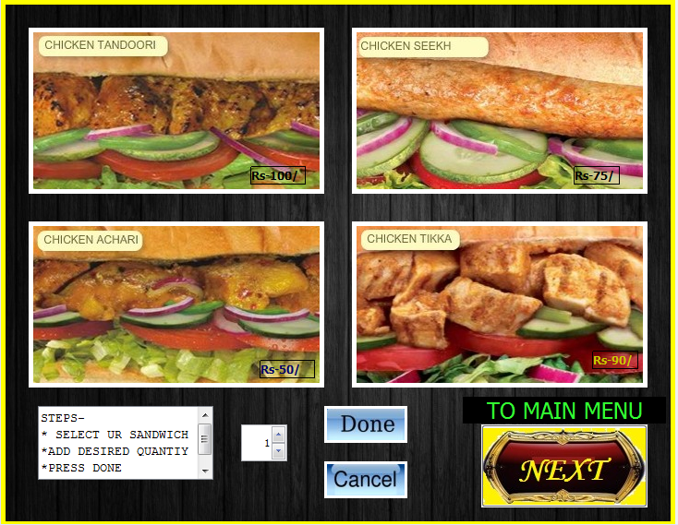

**SOURCE CODE: Local subs.java**

**private void jButton1ActionPerformed(java.awt.event.ActionEvent evt) {**

doneBtn.setEnabled(true);

cancelBtn.setEnabled(true);

jButton2.setEnabled(false);

jButton3.setEnabled(false);

jButton4.setEnabled(false);

}

**private void jButton2ActionPerformed(java.awt.event.ActionEvent evt) {**

doneBtn.setEnabled(true);

cancelBtn.setEnabled(true);

jButton1.setEnabled(false);

jButton3.setEnabled(false);

jButton4.setEnabled(false);

}

**private void jButton3ActionPerformed(java.awt.event.ActionEvent evt) {**

doneBtn.setEnabled(true);

cancelBtn.setEnabled(true);

jButton1.setEnabled(false);

jButton2.setEnabled(false);

jButton4.setEnabled(false);

}

**private void jButton4ActionPerformed(java.awt.event.ActionEvent evt) {**

doneBtn.setEnabled(true);

cancelBtn.setEnabled(true);

jButton1.setEnabled(false);;

jButton2.setEnabled(false);

jButton3.setEnabled(false);

}

**private void cancelBtnActionPerformed(java.awt.event.ActionEvent evt) {**

jButton1.setEnabled(true);

jButton2.setEnabled(true);

jButton3.setEnabled(true);

jButton4.setEnabled(true);

doneBtn.setEnabled(false);

cancelBtn.setEnabled(false);

}

**private void doneBtnActionPerformed(java.awt.event.ActionEvent evt) {**

**try** {

Class.forName("java.sql.Driver");

Connection con = DriverManager.getConnection("jdbc:mysql://localhost:3306/subway","root","123");

String query = "select ID from members where status ='online';";

String query2 = "select name from members where status='online';";

String sno_query="select sno from orders order by sno desc;";

Statement stmt=con.createStatement();

ResultSet rs=stmt.executeQuery(query);

while(rs.next()){

int ID_mysql=Integer.parseInt(rs.getString("ID"));

Statement stmt1 = con.createStatement();

rs = stmt1.executeQuery(query2);

while(rs.next()){

String name_mysql=rs.getString("name");

Statement stmt3=con.createStatement();

rs=stmt3.executeQuery(sno_query);

while(rs.next()){

int sno=Integer.parseInt(rs.getString("sno"));

String item=" ";

int price;

if(jButton1.isEnabled()){

item=" Chicken Tandoori sandwich ";

price=100;

priceLb.setText(""+price);

**}**

else

if(jButton2.isEnabled()){

item=" Chicken achari sandwich ";

price=50;

priceLb.setText(""+price);

**}**

else

if(jButton3.isEnabled()){

item="Chicken seekh sandwich";

price=75;

priceLb.setText(""+price);

**}**

else

if(jButton4.isEnabled()){

item=" Chicken tikka sandwich";

price=90;

priceLb.setText(""+price);

}

Calendar c = Calendar.getInstance();

int price_final = Integer.parseInt(priceLb.getText());

String order = "insert into orders values("+(sno+1)+","+ID_mysql+",'online','"+name_mysql+"','"+item+"',"+Integer.parseInt(priceLb.getText())+","+quantity+",'"+(c.get(Calendar.YEAR))+"-"+(c.get(Calendar.MONTH)+1)+"-"+(c.get(Calendar.DATE))+"','unpaid');" ;

Statement stmt4 = con.createStatement();

stmt4.executeUpdate(order);

String total_collection= "update total_collection set total_money = ( total_money + " + price_final*quantity + ") , total_orders = total_orders +1 ;";

String new_order_placed_today ="insert into total_collection_perday values ('order placed','"+(c.get(Calendar.YEAR))+"-"+(c.get(Calendar.MONTH)+1)+"-"+(c.get(Calendar.DATE))+"',"+price_final*quantity+");";

Statement stmt5=con.createStatement();

Statement stmt6=con.createStatement();

stmt5.executeUpdate(total_collection);

stmt6.executeUpdate(new_order_placed_today);

}

}

}

**catch(Exception e)**{

jButton1.setEnabled(true);

jButton2.setEnabled(true);

jButton3.setEnabled(true);

jButton4.setEnabled(true);

cancelButton.setEnabled(false);

doneButton.setEnabled(false);

thanksMsg.setVisible(true);

dispose();

}

}



**private void jButton6ActionPerformed(java.awt.event.ActionEvent evt) {**

thanksMsg.setVisible(false);

new menu_favourites().setVisible(true); }

**Main Frame: FAVOURITES**

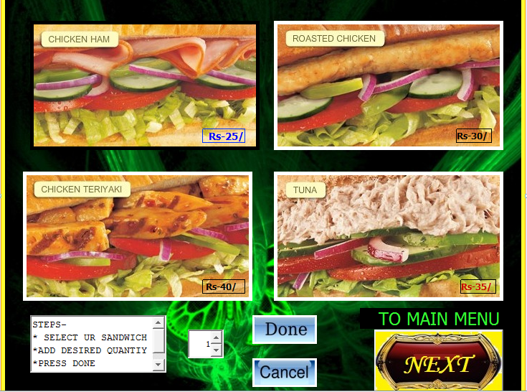

**SOURCE CODE: Favourites.java**

**private void jButton1ActionPerformed(java.awt.event.ActionEvent evt) {**

doneBtn.setEnabled(true);

cancelBtn.setEnabled(true);

jButton2.setEnabled(false);

jButton3.setEnabled(false);

jButton4.setEnabled(false);

**private void jButton2ActionPerformed(java.awt.event.ActionEvent evt) {**

doneBtn.setEnabled(true);

cancelBtn.setEnabled(true);

jButton1.setEnabled(false);

jButton3.setEnabled(false);

jButton4.setEnabled(false);

}

**private void jButton3ActionPerformed(java.awt.event.ActionEvent evt) {**

doneBtn.setEnabled(true);

cancelBtn.setEnabled(true);

jButton1.setEnabled(false);

jButton2.setEnabled(false);

jButton4.setEnabled(false);

}

**private void jButton4ActionPerformed(java.awt.event.ActionEvent evt) {**

doneBtn.setEnabled(true);

cancelBtn.setEnabled(true);

jButton1.setEnabled(false);;

jButton2.setEnabled(false);

jButton3.setEnabled(false);

}

**private void cancelBtnActionPerformed(java.awt.event.ActionEvent evt) {**

jButton1.setEnabled(true);

jButton2.setEnabled(true);

jButton3.setEnabled(true);

jButton4.setEnabled(true);

doneBtn.setEnabled(false);

cancelBtn.setEnabled(false);

}

**private void doneBtnActionPerformed(java.awt.event.ActionEvent evt) {**

**try** {

Class.forName("java.sql.Driver");

Connection con = DriverManager.getConnection("jdbc:mysql://localhost:3306/subway","root","123");

String query = "select ID from members where status ='online';";

String query2 = "select name from members where status='online';";

String sno_query="select sno from orders order by sno desc;";

Statement stmt=con.createStatement();

ResultSet rs=stmt.executeQuery(query);

while(rs.next()){

int ID_mysql=Integer.parseInt(rs.getString("ID"));

Statement stmt1 = con.createStatement();

rs = stmt1.executeQuery(query2);

while(rs.next()){

String name_mysql=rs.getString("name");

Statement stmt3=con.createStatement();

rs=stmt3.executeQuery(sno_query);

while(rs.next()){

int sno=Integer.parseInt(rs.getString("sno"));

String item=" ";

int price;

if(jButton1.isEnabled()){

item="Chicken Ham Sandwich";

price=25;

priceLb.setText(""+price);

**}**

else

if(jButton2.isEnabled()){

item="Chicken Teriyaki Sandwich";

price=40;

priceLb.setText(""+price);

**}**

else

if(jButton3.isEnabled()){

item="Roasted Chicken sandwich";

price=30;

priceLb.setText(""+price);

**}**

else

if(jButton4.isEnabled()){

item="Tuna sandwich";

price=35;

priceLb.setText(""+price);

}

Calendar c = Calendar.getInstance();

int price_final = Integer.parseInt(priceLb.getText());

String order = "insert into orders values("+(sno+1)+","+ID_mysql+",'online','"+name_mysql+"','"+item+"',"+Integer.parseInt(priceLb.getText())+","+quantity+",'"+(c.get(Calendar.YEAR))+"-"+(c.get(Calendar.MONTH)+1)+"-"+(c.get(Calendar.DATE))+"','unpaid');" ;

Statement stmt4 = con.createStatement();

stmt4.executeUpdate(order);

String total_collection= "update total_collection set total_money = ( total_money + " + price_final*quantity + ") , total_orders = total_orders +1 ;";

String new_order_placed_today ="insert into total_collection_perday values ('order placed','"+(c.get(Calendar.YEAR))+"-"+(c.get(Calendar.MONTH)+1)+"-"+(c.get(Calendar.DATE))+"',"+price_final*quantity+");";

Statement stmt5=con.createStatement();

Statement stmt6=con.createStatement();

stmt5.executeUpdate(total_collection);

stmt6.executeUpdate(new_order_placed_today);

}

}

}

**catch(Exception e)**{

jButton1.setEnabled(true);

jButton2.setEnabled(true);

jButton3.setEnabled(true);

jButton4.setEnabled(true);

cancelButton.setEnabled(false);

doneButton.setEnabled(false);

thanksMsg.setVisible(true);

dispose();

}

}



**private void jButton6ActionPerformed(java.awt.event.ActionEvent evt) {**

thanksMsg.setVisible(false);

new menu_favourites().setVisible(true); }

**Main Frame: EXTRAS**

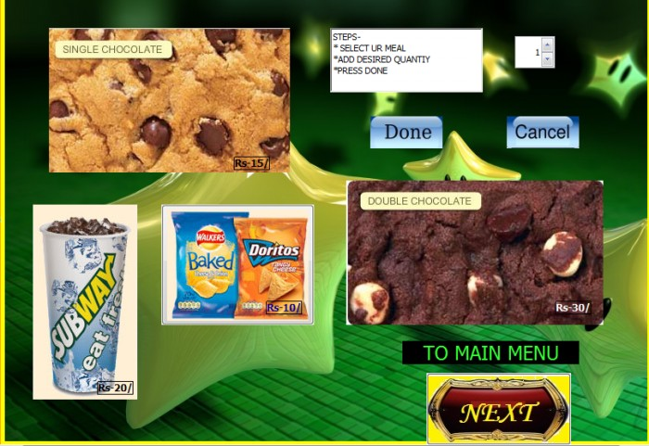

**SOURCE CODE: Extras.java**

**private void jButton1ActionPerformed(java.awt.event.ActionEvent evt) {**

doneBtn.setEnabled(true);

cancelBtn.setEnabled(true);

jButton2.setEnabled(false);

jButton3.setEnabled(false);

jButton4.setEnabled(false);

}

**private void jButton2ActionPerformed(java.awt.event.ActionEvent evt) {**

doneBtn.setEnabled(true);

cancelBtn.setEnabled(true);

jButton1.setEnabled(false);

jButton3.setEnabled(false);

jButton4.setEnabled(false);

}

**private void jButton3ActionPerformed(java.awt.event.ActionEvent evt) {**

doneBtn.setEnabled(true);

cancelBtn.setEnabled(true);

jButton1.setEnabled(false);

jButton2.setEnabled(false);

jButton4.setEnabled(false);

}

**private void jButton4ActionPerformed(java.awt.event.ActionEvent evt) {**

doneBtn.setEnabled(true);

cancelBtn.setEnabled(true);

jButton1.setEnabled(false);;

jButton2.setEnabled(false);

jButton3.setEnabled(false);

}

**private void cancelBtnActionPerformed(java.awt.event.ActionEvent evt) {**

jButton1.setEnabled(true);

jButton2.setEnabled(true);

jButton3.setEnabled(true);

jButton4.setEnabled(true);

doneBtn.setEnabled(false);

cancelBtn.setEnabled(false);

}

**private void doneBtnActionPerformed(java.awt.event.ActionEvent evt) {**

**try** {

Class.forName("java.sql.Driver");

Connection con = DriverManager.getConnection("jdbc:mysql://localhost:3306/subway","root","123");

String query="select ID from members where status='online';";

String query2="select name from members where status='online';";

String sno_query="select sno from orders order by sno desc;";

Statement stmt=con.createStatement();

ResultSet rs=stmt.executeQuery(query);

while(rs.next()){

int ID_mysql=Integer.parseInt(rs.getString("ID"));

Statement stmt1 = con.createStatement();

rs = stmt1.executeQuery(query2);

while(rs.next()){

String name_mysql=rs.getString("name");

Statement stmt3=con.createStatement();

rs = stmt3.executeQuery(sno_query);

while(rs.next()){

int sno = Integer.parseInt(rs.getString("sno"));

String item="";

int price;

if(jButton1.isEnabled()){

item="Double chocolate cookie";

price=30;

priceLb.setText(""+price);

}

else

if(jButton2.isEnabled()){

item="Chips";

price=10;

priceLb.setText(""+price);

}

else

if(jButton3.isEnabled()){

item="Chocolate Cookie";

price=15;

priceLb.setText(""+price);

}

else

if(jButton4.isEnabled()){

item="Coke";

price=20;

priceLb.setText(""+price);

}

Calendar c = Calendar.getInstance();

int price_final = Integer.parseInt(priceLb.getText());

String order ="insert into orders values("+(sno+1)+","+ID_mysql+",'online','"+name_mysql+"','"+item+"',"+Integer.parseInt(priceLb.getText())+","+quantity+",'"+(c.get(Calendar.YEAR))+"-"+(c.get(Calendar.MONTH)+1)+"-"+(c.get(Calendar.DATE))+"','unpaid');" ;

Statement stmt4=con.createStatement();

stmt4.executeUpdate(order);

String total_collection= "update total_collection set total_money = ( total_money + " + price_final*quantity + ") , total_orders = total_orders +1 ;";

String new_order_placed_today ="insert into total_collection_perday values ('order placed','"+(c.get(Calendar.YEAR))+"-"+(c.get(Calendar.MONTH)+1)+"-"+(c.get(Calendar.DATE))+"',"+price_final*quantity+");";

Statement stmt5 = con.createStatement();

Statement stmt6=con.createStatement();

stmt5.executeUpdate(total_collection);

stmt6.executeUpdate(new_order_placed_today);

}

}

}

jButton1.setEnabled(true);

jButton2.setEnabled(true);

jButton3.setEnabled(true);

jButton4.setEnabled(true);

cancelBtn.setEnabled(false);

doneBtn.setEnabled(false);

thanksMsg.setVisible(true);

dispose();

}

**catch(Exception e)**{

jButton1.setEnabled(true);

jButton2.setEnabled(true);

jButton3.setEnabled(true);

jButton4.setEnabled(true);

cancelBtn.setEnabled(false);

doneBtn.setEnabled(false);

thanksMsg.setVisible(true);

dispose();

}

}



**private void jButton6ActionPerformed(java.awt.event.ActionEvent evt) {**

thanksMsg.setVisible(false);

new menu_favourites().setVisible(true);

}

**Main Frame: Bill**

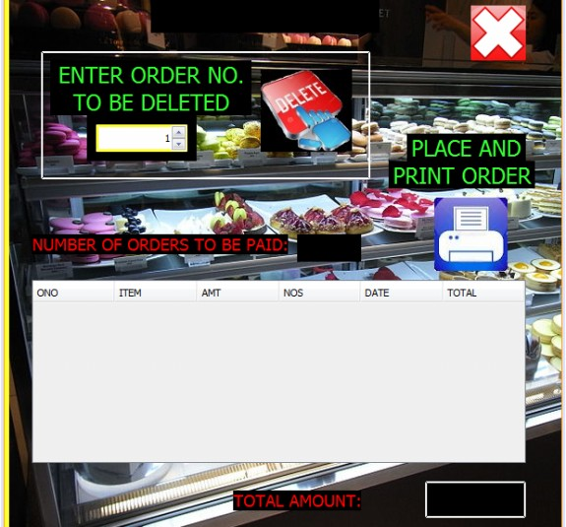

**SOURCE CODE: Bill.java**

public void add_records_in_table(){

**try**{

Class.forName("java.sql.Driver");

Connection con=DriverManager.getConnection("jdbc:mysql://localhost:3306/subway","root","123");

Statement stmt=con.createStatement();

Statement stmt1=con.createStatement();

String count_of_records = "select count(*) as count from orders where logged_in='online' and status='unpaid';";

String orders="select * from orders where logged_in='online' and status='unpaid';";

ResultSet rs = stmt1.executeQuery(count_of_records);

while(rs.next()){

int number=Integer.parseInt(rs.getString("count"));

no.setText(""+ number);

DefaultTableModel tables1 =(DefaultTableModel)info.getModel() ;

int count=info.getRowCount();

int m;

for(m=count; m>0; m--){

tables1.removeRow(0);

}

info.setModel(tables1);

rs = stmt.executeQuery(orders);

int i;

int sum=0;

for(i=number;i>=0;i--){

while(rs.next()){

int sno = Integer.parseInt(rs.getString("sno"));

String item_ordered = rs.getString("item_ordered");

double amount = Double.parseDouble(rs.getString("amount"));

double quantity=Double.parseDouble(rs.getString("quantity"));

String date_ordered=rs.getString("date_ordered");

double total= (amount*quantity);

DefaultTableModel tables=(DefaultTableModel)info.getModel();

Object [] names_found = {sno, item_ordered, amount, quantity, date_ordered,total};

tables.addRow(names_found);

sum += total;

}

total.setText(""+sum+"/-");

}

}

}

**catch(Exception e)**{

JOptionPane.showMessageDialog(null, e.getMessage());

}

}

**private void jButton1ActionPerformed(java.awt.event.ActionEvent evt) {**

new main_menu().setVisible(true);

dispose();

}

**private void formWindowGainedFocus(java.awt.event.WindowEvent evt) {**

Calendar c=Calendar.getInstance();

date.setText("" +c.getTime());

add_records_in_table();

}

**private void jButton2ActionPerformed(java.awt.event.ActionEvent evt) {**

int order_no=(Integer)(sp.getValue());

**try** {

Class.forName("java.sql.Driver");

Connection con = DriverManager.getConnection("jdbc:mysql://localhost:3306/subway","root","123");

String delete_records_from_orders="delete from orders where sno ="+ order_no +";";

Statement stmt1 = con.createStatement();

stmt1.executeUpdate(delete_records_from_orders);

refresh.doClick();

}

**catch(Exception e)**{

JOptionPane.showMessageDialog(this,e.getMessage());

}

}

**private void refreshActionPerformed(java.awt.event.ActionEvent evt) {**

add_records_in_table();

}

**private void jButton4ActionPerformed(java.awt.event.ActionEvent evt) {**

int confirm=JOptionPane.showConfirmDialog(null, "ORDER ONCE PLACED CANNOT BE CANCELLED. ARE YOU SURE.");

if(confirm==0){

**try** {

Class.forName("java.sql.Driver");

Connection con = DriverManager.getConnection("jdbc:mysql://localhost:3306/subway","root","123");

Statement stmt=con.createStatement();

String update_orders= "update orders set status = 'paid' where logged_in = 'online';";

stmt.executeUpdate(update_orders);

new user_dashboard().setVisible(true);

JOptionPane.showMessageDialog(null, "YOUR ORDER HAVE BEEN PLACED. PLEASE COLLECT YOUR MEAL AT THE COUNTER AND PAY THE MONEY. THANKYOU. ") k dispose();

}

**catch(Exception e**){

JOptionPane.showMessageDialog(null,e.getMessage());

}

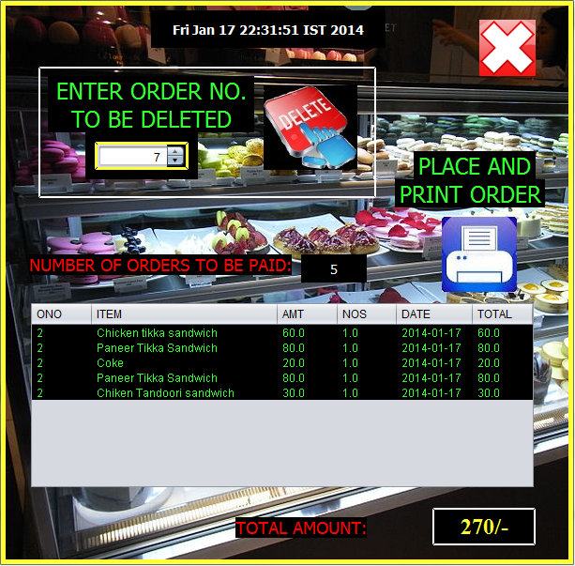

**Main Frame: HISTORY**

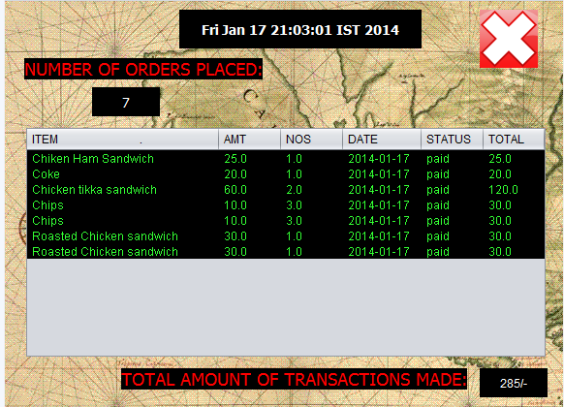

**SOURCE CODE: History.java**

**private void jButton1ActionPerformed(java.awt.event.ActionEvent evt) {**

new user_dashboard().setVisible(true);

dispose();

}

**private void formWindowGainedFocus(java.awt.event.WindowEvent evt) {**

Calendar c = Calendar.getInstance();

date.setText("" +c.getTime());

**try**{

Class.forName("java.sql.Driver");

Connection con = DriverManager.getConnection("jdbc:mysql://localhost:3306/subway","root","123");

Statement stmt=con.createStatement();

Statement stmt1=con.createStatement();

String count_of_records="select count(*) as count from orders where logged_in='online';";

String orders="select * from orders where logged_in='online';";

ResultSet rs = stmt1.executeQuery(count_of_records);

while(rs.next()){

int number = Integer.parseInt(rs.getString("count"));

if(number==0){

new user_dashboard().setVisible(true);

JOptionPane.showMessageDialog(null, "YOU HAVE NOT PLACED ANY ORDER YET !");

dispose();

}

else{

rs = stmt.executeQuery(orders);

int i;

int sum=0;

for(i=number;i>=0;i--){

while(rs.next()){

String item_ordered = rs.getString("item_ordered");

double amount=Double.parseDouble(rs.getString("amount"));

double quantity=Double.parseDouble(rs.getString("quantity"));

String date_ordered=rs.getString("date_ordered");

String status=rs.getString("status");

double total= (amount*quantity);

DefaultTableModel tables = (DefaultTableModel)info.getModel();

Object [] names_found = {item_ordered, amount, quantity, date_ordered, status,total};

tables.addRow(names_found);

sum += total;

}

total.setText(""+sum+"/-");

no.setText(""+ info.getRowCount());

}

}

}

}

**catch(Exception e)**{

JOptionPane.showMessageDialog(null, e.getMessage());

}

}

**OWNERS SECTION**

**Main Frame: Owner User**

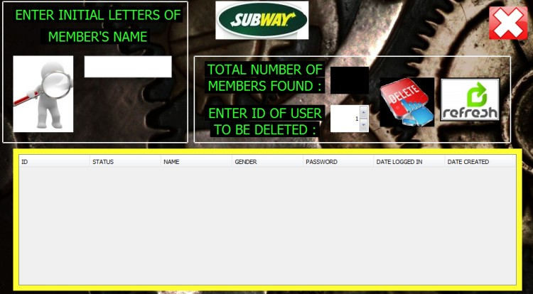

**SOURCE CODE: Owner User.java**

public void search_database(){

String key=(match.getText().toLowerCase());

**try**{

Class.forName("java.sql.Driver");

Connection con = DriverManager.getConnection("jdbc:mysql://localhost:3306/subway","root","123");

Statement stmt = con.createStatement();

String match="select count(*) as total_no_of_members from members where name like '"+key+"%';";

ResultSet rs = stmt.executeQuery(match);

while(rs.next()){

String number1 = rs.getString("total_no_of_members");

int number = Integer.parseInt(number1);

String search = "select * from members where name like '"+key+"%' ;";

Rs = stmt.executeQuery(search);

DefaultTableModel tables = (DefaultTableModel)tbl.getModel() ;

int count=tables.getRowCount();

int m;

for (m=count; m>0; m--){

tables.removeRow(0);

}

tbl.setModel(tables);

int i;

for(i=number;i>=0;i--){

while(rs.next()){

int ID=Integer.parseInt(rs.getString("ID"));

String status=rs.getString("status");

String name=rs.getString("name");

String gender=rs.getString("gender");

String password=rs.getString("password");

String date_last_logged_in=rs.getString("date_last_logged_in");

String date_created=rs.getString("date_created");

Object [] names_found = { ID, status, name, gender, password, date_last_logged_in, date_created };

DefaultTableModel table = (DefaultTableModel)tbl.getModel() ;

table.addRow(names_found);

}

}

no.setText(""+ tbl.getRowCount());

}

}

**catch(Exception e)**{

JOptionPane.showMessageDialog(null, e.getMessage());

}

}

**private void jButton1ActionPerformed(java.awt.event.ActionEvent evt) {**

new owners_dashboard().setVisible(true);

dispose();

}

**private void jButton2ActionPerformed(java.awt.event.ActionEvent evt) {**

int id=(Integer)(sp.getValue());

if(id==101){

JOptionPane.showMessageDialog(null, "SORRY!. THIS ACCOUNT BELONGS TO THE OWNER AND CANNOT BE DELETED.");

}

else{

**try** {

Class.forName("java.sql.Driver");

Connection con = DriverManager.getConnection("jdbc:mysql://localhost:3306/subway","root","123");

String delete_records_from_members="delete from members where ID ="+ id +" ;";

String delete_records_from_contact_info="delete from contact_info where ID ="+ id +" ;";

String delete records from orders = "delete from orders where ID ="+ id +" ;";

Statement stmt1=con.createStatement();

Statement stmt2=con.createStatement();

Statement stmt3=con.createStatement();

stmt1.executeUpdate(delete_records_from_members);

stmt2.executeUpdate(delete_records_from_contact_info);

stmt3.executeUpdate(delete_records_from_orders);

JOptionPane.showMessageDialog(null, "ACCOUNT DELETED.");

con.close();

}

**catch(Exception e)**{

JOptionPane.showMessageDialog(this,e.getMessage());

}

}

}

**private void jButton3ActionPerformed(java.awt.event.ActionEvent evt) {**

search_database();

}

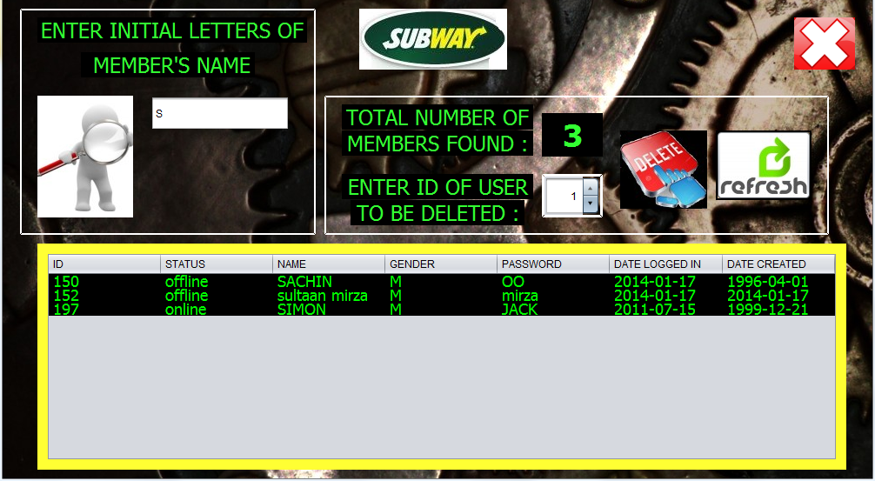

**Main Frame: Owner Profile**

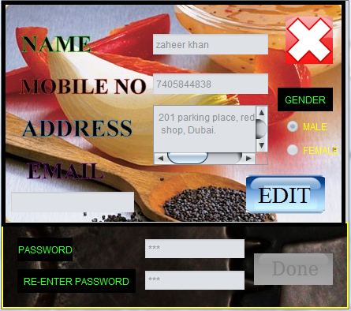

**SOURCE CODE: Owner profile.java**

**private void gActionPerformed(java.awt.event.ActionEvent evt) {**

String name=a.getText().trim().toLowerCase();

String gender="";

if(e.isSelected())

gender = "M";

else

gender = "F";

String address=c.getText().trim().toLowerCase();

String email_id = d.getText().trim().toLowerCase();

String password= "";

String password1 = new String(h.getPassword());

String password2 = new String(i.getPassword());

if(password1.equals(password2)){

password=password1;

}

else{

JOptionPane.showMessageDialog(null, "the password you entered didn’t matched, please try again");

g.doClick();

}

if(name.equals("")|| password.equals("")||email_id.equals("")||address.equals(""))

JOptionPane.showMessageDialog(null, "All fields are mandatory.");

else{

**try** {

long mobile = Long.parseLong(b.getText());

Class.forName("java.sql.Driver");

Connection con=DriverManager.getConnection("jdbc:mysql://localhost:3306/subway","root","123");

Statement stmt=con.createStatement();

Statement stmt1=con.createStatement();

Statement stmt2=con.createStatement();

String update_members="update members set name='"+ name +"' , gender='"+gender+"' , password='"+password+"'where ID=101 ;";

String update_contact_info= "update contact_info set name='"+ name +"' , mobile_no="+mobile+" ,email='"+email_id+"' , address='"+address+"' where ID=101 ;";

String update_orders= "update orders set name='"+ name +"' where ID=101 ;";

stmt.executeUpdate(update_members);

stmt1.executeUpdate(update_contact_info);

stmt2.executeUpdate(update_orders);

stmt.close();

con.close();

JOptionPane.showMessageDialog(null, "changes saved successfully");

new owners_dashboard().setVisible(true);

dispose();

}

**catch(Exception e)**{

JOptionPane.showMessageDialog(this,e.getMessage());

dispose();

}

}

}

private void bFocusLost(java.awt.event.FocusEvent evt) {

String mobile=b.getText().trim();

if(mobile.equals("")){

JOptionPane.showMessageDialog(null, "this field is mandatory.");

}

else{

int initial_digit=Integer.parseInt(mobile.substring(0, 1));

int length=mobile.length();

if(length==10){

if(initial_digit==8|| initial_digit==9 || initial_digit==7){

String duplicate_check="select mobile_no from contact_info where mobile_no="+mobile+" and status='offline' and ID>101 ;";

**try**{

Class.forName("java.sql.Driver");

Connection con = DriverManager.getConnection("jdbc:mysql://localhost:3306/subway","root","123");

Statement stmt=con.createStatement();

ResultSet rs=stmt.executeQuery(duplicate_check);

while(rs.next()){

String mysql_mobno=(rs.getString("mobile_no")).toLowerCase().trim();

if(mobile.equals(mysql_mobno)){

JOptionPane.showMessageDialog(null, "Sorry! this number has already been taken by our existing user. please try a different mobile number.");

b.setText("");

}

}

**catch(Exception e)**{

JOptionPane.showMessageDialog(null, e.getMessage());

}

}

else{

JOptionPane.showMessageDialog(null, "This kind of mobile number does not exist in India. Please enter a VALID number.");

b.setText("");

}

}

else{

JOptionPane.showMessageDialog(null, "Please enter a 10 digit number ONLY");

b.setText("");

}

}

}

private void bKeyTyped(java.awt.event.KeyEvent evt) {

char ch = evt.getKeyChar();

if( ((ch>='0') && (ch<='9')) ){

evt.consume();

}

}

**private void jButton1ActionPerformed(java.awt.event.ActionEvent evt) {**

new owners_dashboard().setVisible(true);

dispose();

}

**Main Frame: OWNERS DASHBOARD**

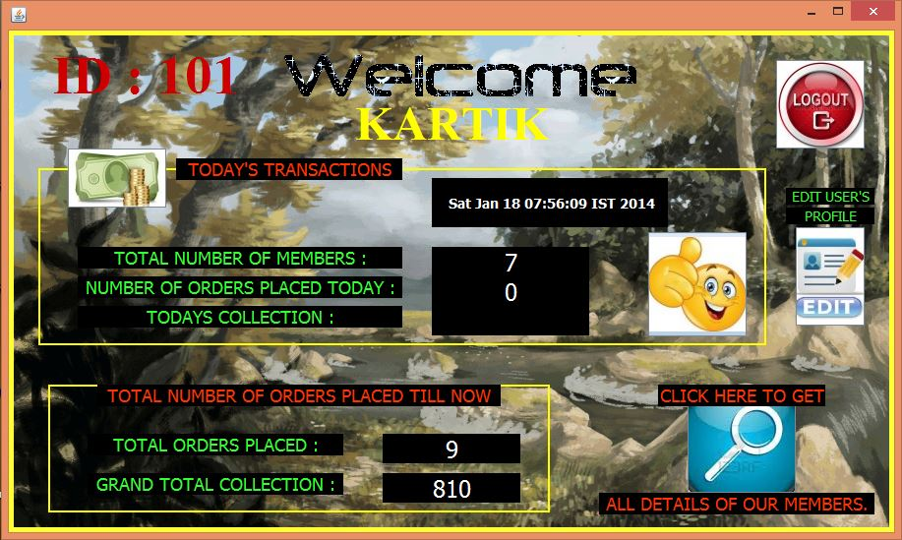

**SOURCE CODE: Owners Dashboard.java**

**private void jButton1ActionPerformed(java.awt.event.ActionEvent evt) {**

new Owners_user__search().setVisible(true);

dispose();

}

**private void jButton2ActionPerformed(java.awt.event.ActionEvent evt) {**

new LOGIN_FORM().setVisible(true);

dispose();

}

**private void jButton3ActionPerformed(java.awt.event.ActionEvent evt) {**

new edit_owners_profile().setVisible(true);

dispose();

}

**private void formWindowGainedFocus(java.awt.event.WindowEvent evt) {**

Calendar c = Calendar.getInstance()

datelb.setText(" " +c.getTime());

**try** {

Class.forName("java.sql.Driver");

Connection con = DriverManager.getConnection("jdbc:mysql://localhost:3306/subway","root","123");

Statement stmt=con.createStatement();

Statement stmt1=con.createStatement();

Statement stmt2=con.createStatement();

String present_members= "Select count(*) as number from members;";

String total_transaction="SELECT total_orders , total_money FROM total_collection ;";

String transaction_done_today="SELECT COUNT(*) as recent_count, sum(amount) as recent_total FROM total_collection_perday WHERE date='"+(c.get(Calendar.YEAR))+"-"+(c.get(Calendar.MONTH)+1)+"-"+(c.get(Calendar.DATE))+"' ;";

ResultSet rs = stmt.executeQuery(present_members);

while(rs.next()){

tot_no.setText(rs.getString("number"));

rs = stmt1.executeQuery(total_transaction);

while(rs.next()){

tot_orders.setText(rs.getString("total_orders"));

grand_total.setText(rs.getString("total_money"));

rs = stmt2.executeQuery(transaction_done_today);

while(rs.next()){

no_of_order.setText(rs.getString("recent_count"));

tot_amt.setText(rs.getString("recent_total"));

}

}

}

**catch(Exception e)**{

}

}

**bibliography:-**

* **IP textbook of class XII by Sumita Arora**
* [**www.subway.co.in**](http://www.subway.co.in)
* [**www.Wikipedia.com**](http://www.Wikipedia.com)
* **www.Google.com**